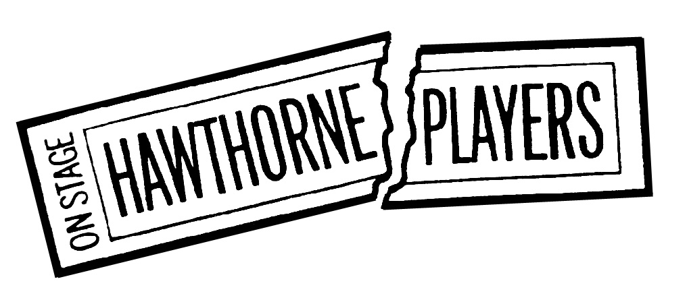
Director’s Application for 2023 Season
Email to Hawthorne_Players@yahoo.com by July 22, 2022

Name:

Address:

Phone:

E-Mail:

Type: Play Musical

Show Title:

Playwright:

Cast Size: Period of Show:

Rights (MTI, Samuel French, Dramatists, etc.):

- Why do you feel this show is a good choice for Hawthorne’s 2023 season?

- Synopsis (feel free to copy directly from the rights-holder’s website)

- Summarize your vision for staging (standard/traditional sets, costumes, overall staging or something unique/unexpected)

- Attach a summary/resume of your theatrical experience.

Production Staff: While the Board will assist whenever possible, Hawthorne Directors are responsible for securing the show’s production team, including an Assistant Director, Stage Manager, Set Designer, Master Carpenter, Lighting Designer, Sound Designer and Costumer, as well as Music Director and Choreographer for musicals.

Identifying the team is not required with the initial submission, however, a discussion with the Hawthorne Board about potential staff may take place before final director selections are made.

