**2022 *Season Ticket Order Form***

***The Hawthorne Players of Florissant***



The Hawthorne Players proudly present their 75th season of Live Theatre! Below is an order form with a special rate for season ticket holders for this incredible season. The season consists of the three shows (details on website). We also are presenting two Best of Hawthorne performances. Season subscribers get a special discount when purchasing with your season order. We can’t wait to see you at the theatre!

**

SEP 10

Plus

DEC 10

MAR 25, 26 APR 1, 2, 3 JUL 29, 30 AUG 5, 6, 7 NOV 4, 5, 11, 12, 13

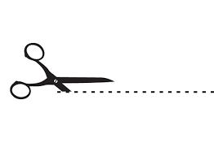

………………………………………………………………………………………………………………………………………………………………………

**HAWTHORNE PLAYERS 2022 Pro-Rated Remaining SEASON TICKET FORM**

____________________________________________ ___________________________________________________

Name (Please Print) Address

______________________________ _____ _______________ ____________________ _______________________

City State Zip Phone Email

**TICKET ORDER** **PAYMENT METHOD**

2 Show Season _____ X $37.50 = __________

9/10 75th Revue _____ X $10.00 = __________

12/12 *Cowboy Xmas* _____ X $10.00 = ___________

(Select date/time below for each show)

\**Keep Live Theatre Alive* __________ (Optional Donation)

**GRAND TOTAL $ __________________**

**CIRCLE SHOW DATES**

**MAIL TO:**

Hawthorne Season Tickets

c/o Colleen Heneghan

10504 Williamsfield Dr

St Louis, MO 63135